Geometry: Unit 6, Lesson H2

- The ratio between the circumference of circle $W$ and circle $B$ is $\frac{4}{5}$. What is the circumference of circle $B$ if the radius of circle $W$ is $12$ inches?

$$94.2$$

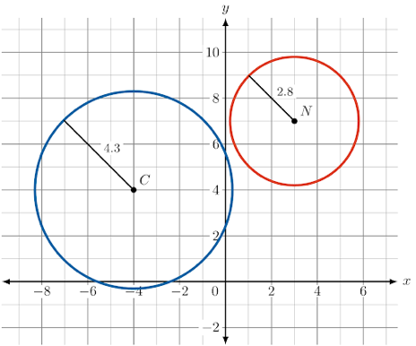
- Circle $C$ and circle $N$ are shown on the coordinate plane. What is the ratio of the radius of circle $C$ to the radius of circle $N$?

$$1.536$$

- Circle $K$ has a radius of $5.4$. What is the circumference of Circle $K$?

$$33.912$$

